A Report

on

SPENDWISE: AN AI-POWERED UPI EXPENSE TRACKER

carried out as part of the course Project Based Learning- 4
Submitted by

Vaishnavi Kaushal

23FE10CSE00480

VI Semester

in partial fulfilment for the award of the degree

of

BACHELOR OF TECHNOLOGY

In

Computer Science & Engineering



Department of Computer Science & Engineering,
School of Computer Science and Engineering,
Manipal University Jaipur,
Jan-May 2026

A Report

on

SPENDWISE: AN AI-POWERED UPI EXPENSE TRACKER

carried out as part of the course Project Based Learning- 4
Submitted by

Vaishnavi Kaushal

23FE10CSE00480

VI Semester

in partial fulfilment for the award of the degree

of

BACHELOR OF TECHNOLOGY

In

Computer Science & Engineering

Under the Guidance of :

Guide Name : …………………………………………….

Guide Signature(with date) : ………………………………………

Acknowledgement

This project would not have been completed without the help, support, comments, advice, cooperation and coordination of various people. However, it is impossible to thank everyone individually; I am hereby making a humble effort to thank some of them.

I acknowledge and express my deepest sense of gratitude to my internal supervisor …………………………………. for his/her constant support, guidance, and continuous engagement. I highly appreciate his technical comments, suggestions, and criticism during the progress of this project titles “………………………………….”.

I owe my profound gratitude to Dr. Neha Chaudhary , Head, Department of CSE, for her valuable guidance and for facilitating me during my work. I am also very grateful to all the faculty members and staff for their precious support and cooperation during the development of this project.

Finally, I extend my heartfelt appreciation to my classmates for their help and encouragement.

Vaishnavi Kaushal

23FE10CSE00480



Department of Computer Science and Engineering
School of Computer Science and Engineering

Date: _____________

CERTIFICATE

This is to certify that the project entitled “Spendwise: An AI-Powered UPI Expense Tracker" is a bonafide work carried out as PBL-4 End Term Assessment in partial fulfillment for the award of the degree of Bachelor of Technology in Computer Science and Engineering, by Vaishnavi Kaushal bearing registration number 23FE10CSE00480 , during the academic semester VI of year 2025-2026.

Place: Manipal University Jaipur, Jaipur

Name of the project guide: ________________________

Signature of the project guide: ______________________

Abstract
SpendWise is a full-stack, AI-augmented web application designed to automate UPI expense tracking for Indian college students without requiring bank account linkage. The system enables users to paste SBI UPI SMS notifications, which are parsed using regular expressions across two distinct message formats to automatically extract merchant name, transaction amount, date, and type. Extracted transactions are stored in a Supabase PostgreSQL database secured with Row-Level Security and JWT authentication.
The application integrates a multi-model AI pipeline powered by the Groq API. Unknown vendor names are classified using zero-shot LLM classification (Groq LLaMA 3.3-70b-versatile) with confidence scores and explainable AI (XAI) reasoning displayed to the user. A LLaMA 4 Scout vision model enables receipt scanning, extracting structured transaction data from uploaded receipt photographs. Personalized financial coaching is delivered through a context-augmented LLaMA 3.3 prompt that uses the user's actual category-wise spending totals. Spend forecasting uses a Weighted Moving Average algorithm to project month-end expenditure with a confidence verdict.
The frontend is built with React.js and Vite, deployed on Vercel, while the backend uses Node.js and Express.js, deployed on Render. The application features an interactive analytics dashboard with category-split donut charts, weekly bar charts, month-switcher navigation across six months, per-category budget goals with progress tracking, and mobile-responsive design. SpendWise addresses critical gaps identified in existing literature — specifically the absence of web-based UPI trackers with LLM integration, receipt OCR pipelines, and AI-powered contextual coaching tailored to Indian student spending patterns.

Keywords: UPI Expense Tracking, Large Language Models, Zero-Shot Classification, Receipt OCR, Weighted Moving Average, React.js, Node.js, Supabase, Groq API, Full-Stack Web Application

Contents

Page No.
- Introduction………………………………………………………………… .8
  - Objective of the project……………………………………………….8
  - Brief description of the project………………………………………..8
  - Technology used………………………………………………………9
    - H / W Requirement…………………………………………….9
    - Software Requirement………………………………………….9
  - Organization Profile ………………………………………………….10
- Design Description
  - System Flow Chart……………………………………………………11
  - Data Flow Diagrams(DFDs).................................................................13
    - Level-0 DFD
    - Level-1 DFD
  - Entity Relationship Diagram(E-R Diagram)………………………….16
- Project Description
  - Database……………………………………………………………….18
  - Table Description…………………………………………………….. 18
  - File/Database Design..............................................................................19
- Input/Output Form Design
  - Input Froms.............................................................................................21
    - SMS Input Form
    - Manual Entry Form
    - Receipt Scanner
    - Budget Goal Input
  - Output Forms..........................................................................................24
    - Dashboard Overview
    - Transactions List
    - Analytics Charts
    - Spend Forecast Output
    - AI Vendor Categorizer Popup
    - Budget Progress Cards
- Testing & Tools used
  - Testing Approach……………………………………………………… 28
  - API Endpoint…………………………………………………………... 28
  - SMS Parsing Test Cases……………………………………………….. 29
  - AI Feature Testing………………………………………………………29
  - Deployment Testing…………………………………………………….29
  - Tools Used………………………………………………………………30
- Implementation & Maintenance (if applicable)
  - Implementation Details………………………………………………….31
    - SMS Parsing Implementation
    - AI Pipeline Implementation
    - Weighted Moving Average forecast
    - Authentication & Security
  - Deployment Architecture………………………………………………..32
  - Maintenance Considerations…………………………………………….32
- Conclusion and Future Work
  - Conclusion………………………………………………………………34
  - Future Work……………………………………………………………..34
- Outcome……………………………………………………………………….. 36
- Bibliography…………………………………………………………………… 37

1. Introduction

1.1 Objective of the Project
The primary objective of SpendWise is to design, develop, and deploy a full-stack AI-augmented web application that automates UPI expense tracking for Indian college students through regex-based SBI SMS parsing, LLM-powered zero-shot vendor categorization with explainability, Vision AI receipt scanning, and Weighted Moving Average spend forecasting — without requiring bank account linkage. The project further aims to provide personalized AI financial coaching grounded in the user's actual historical spending data, enabling data-driven financial self-awareness for students in the Indian UPI ecosystem.

1.2 Brief Description of the Project
SpendWise is a production-deployed web application that addresses a critical gap in the Indian personal finance landscape: the absence of a lightweight, privacy-respecting, AI-powered expense tracker tailored to UPI users. India processed over 100 billion UPI transactions in 2023, yet most students have no automated way to aggregate or understand their spending from ephemeral SMS notifications.
The application accepts SBI UPI SMS notifications pasted by the user and uses regular expressions to extract transaction details across two distinct message formats. Transactions are automatically categorized into ten spending categories using a keyword-based merchant map. Unknown vendors are sent to Groq's LLaMA 3.3 for zero-shot classification, with confidence scores and explainable AI reasoning presented to the user. The system also accepts receipt photographs, using LLaMA 4 Scout's Vision AI to extract structured transaction data via OCR.
All data is stored in Supabase PostgreSQL with Row-Level Security policies ensuring strict data isolation between users. The analytics dashboard provides category-split donut charts, weekly trend bar charts, month-switching navigation, budget goal tracking with animated progress bars, and a floating AI financial coach that generates personalized 5-card emoji-structured insights. A Weighted Moving Average algorithm forecasts month-end spending with a confidence verdict. The application is fully deployed — frontend on Vercel (https://spendwise-woad.vercel.app) and backend on Render.

1.3 Technology Used

1.3.1 Hardware Requirements
The following hardware configuration was used for development and testing of SpendWise:
- Processor: Intel Core i5 (8th Gen) or equivalent — 2.4 GHz or higher
- RAM: 8 GB minimum (16 GB recommended for running local development servers simultaneously)
- Storage: 20 GB free disk space for project files, node_modules, and build artifacts
- Network: Broadband internet connection (required for Supabase, Render, Vercel, and Groq API calls)
- Display: 1366 x 768 resolution or higher

1.3.2 Software Requirements
The following software tools, frameworks, and services were used in the development of SpendWise:

Table 1.1: Software Requirements
Category | Technology / Tool | Purpose
Frontend | React.js + Vite | Component-based UI with fast HMR build system
Frontend | Framer Motion | Animations, transitions, and gesture interactions
Frontend | Recharts | Interactive donut charts, bar charts, and line charts
Frontend | Axios | HTTP client for REST API calls to backend
Backend | Node.js + Express.js | RESTful API server with 15 endpoints
Backend | JWT (jsonwebtoken) | Stateless user authentication and session management
Database | Supabase (PostgreSQL) | Relational database with Row-Level Security
AI / LLM | Groq API – LLaMA 3.3-70b | Zero-shot vendor classification and AI coaching
AI / LLM | Groq – LLaMA 4 Scout Vision | Receipt OCR and structured data extraction
Deployment | Vercel | Frontend hosting with auto-deploy from GitHub
Deployment | Render | Backend Node.js server hosting (free tier)
Version Control | Git + GitHub | Source control and collaborative code management
IDE | Visual Studio Code | Primary development environment
Runtime | Node.js v18+ | JavaScript runtime for backend execution

1.4 Organization Profile
SpendWise is an academic project developed independently by Vaishnavi Kaushal (Registration No. 23FE10CSE00480), a VI Semester student of the Department of Computer Science and Engineering, School of Computer Science and Engineering, Manipal University Jaipur. The project is submitted in partial fulfillment of the Project Based Learning (PBL-4) course under the supervision of Dr. Babita Tiwari.
The project is not associated with any external organization. All development was done individually, and all external services used (Supabase, Groq API, Vercel, Render) are accessed through their free-tier public APIs under standard usage terms.

2. Design Description

2.1 System Flowchart
Figure 2.1 illustrates the high-level flow of the SpendWise application from user input through AI processing to dashboard visualization.

The system flow proceeds as follows:
- User visits the SpendWise web application and authenticates via email/password (JWT issued).
- User pastes one or more SBI UPI SMS messages into the input area. A live preview immediately shows parsed transactions using regex extraction.
- On save, transactions are sent to the backend via POST /api/transactions/bulk.
- The regex parser extracts: merchant name, amount, date, transaction type, and raw SMS.
- The localStorage vendor memory map is checked first. If the vendor is recognized, the stored category is applied instantly.
- If the vendor falls in the 'Other' category, the AI Vendor Categorizer popup triggers, calling POST /api/ai/categorize-vendor (Groq LLaMA 3.3 zero-shot classification).
- The user reviews the AI suggestion (confidence % + XAI reasoning) and confirms or changes the category. The confirmed mapping is saved to localStorage for future instant recall.
- All transactions are stored in Supabase PostgreSQL with Row-Level Security.
- The dashboard fetches and displays: category-split charts, weekly trends, month-filtered transactions, budget progress, and spend forecast.
- The AI Financial Coach (floating bubble) sends spending totals to LLaMA 3.3 for contextual personalized financial insights.

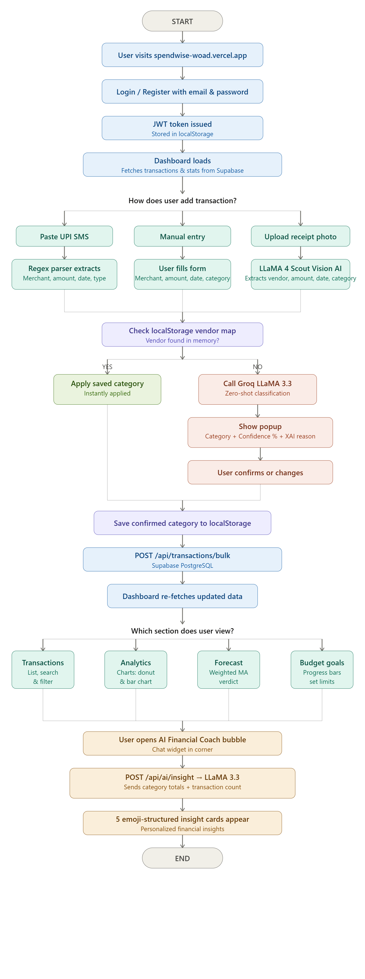

Figure 2.1: SpendWise System Flowchart
An alternate input path allows users to upload a receipt photograph. The receipt is sent to LLaMA 4 Scout (Vision AI) via POST /api/ai/scan-receipt, which returns structured data (vendor, amount, date, category). The user confirms before saving.

2.2 Data Flow Diagrams (DFDs)

2.2.1 Level-0 DFD (Context Diagram)
The Level-0 DFD shows SpendWise as a single process interacting with three external entities:
- User: Provides UPI SMS input, receipt images, budget limits, and confirmation actions. Receives dashboard analytics, AI insights, and spend forecasts.
- Groq API: Receives vendor classification requests and receipt image payloads. Returns LLM-generated category predictions, XAI reasoning, and receipt extraction results.
- Supabase (PostgreSQL): Stores and retrieves transactions, budgets, and user account data with Row-Level Security.
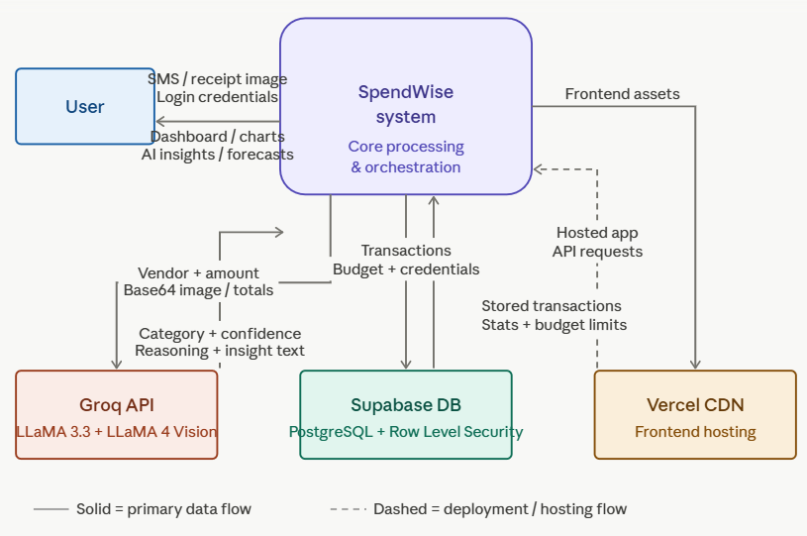
Figure 2.2: Level-0 DFD — SpendWise Context Diagram

2.2.2 Level-1 DFD
The Level-1 DFD decomposes the system into the following major processes:
- Process 1.0 — User Authentication: Handles registration and login. Issues JWT tokens stored in the browser's localStorage for stateless session management.
- Process 2.0 — Transaction Ingestion: Accepts SMS text or receipt image. Applies regex parsing (SMS) or Vision AI extraction (receipt). Triggers vendor categorization flow.
- Process 3.0 — AI Vendor Categorization: Checks localStorage vendor memory. If unknown, calls Groq LLaMA 3.3 for zero-shot classification. Receives user confirmation and updates transaction category via PATCH /api/transactions/:id/category.
- Process 4.0 — Data Storage: Saves transactions and budgets to Supabase PostgreSQL. Enforces Row-Level Security so each user accesses only their own data.
- Process 5.0 — Analytics & Reporting: Fetches month-filtered transactions and stats. Computes category breakdown and weekly trends for charts.
- Process 6.0 — AI Financial Coach: Sends spending totals and category breakdown to LLaMA 3.3. Parses emoji-structured response into animated insight cards.
- Process 7.0 — Spend Forecast: Applies Weighted Moving Average to current month's daily spending. Projects month-end total and generates confidence verdict.
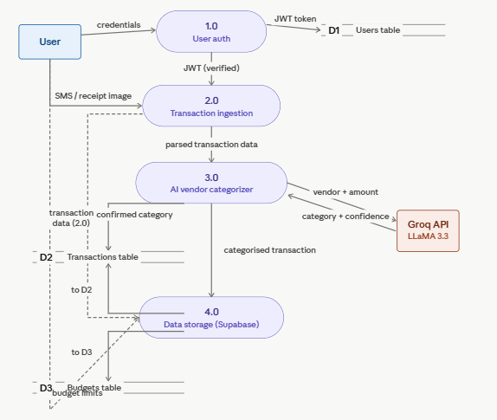
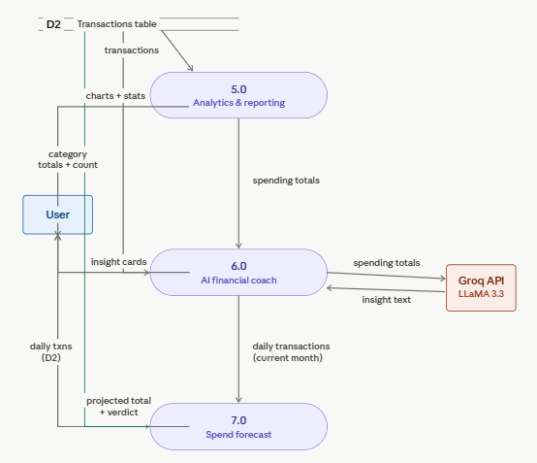
Figure 2.3: Level-1 DFD — SpendWise Major Processes

2.3 Entity Relationship Diagram (E-R Diagram)
The SpendWise database consists of three primary entities hosted in Supabase PostgreSQL. The E-R diagram captures the relationships between Users, Transactions, and Budgets.
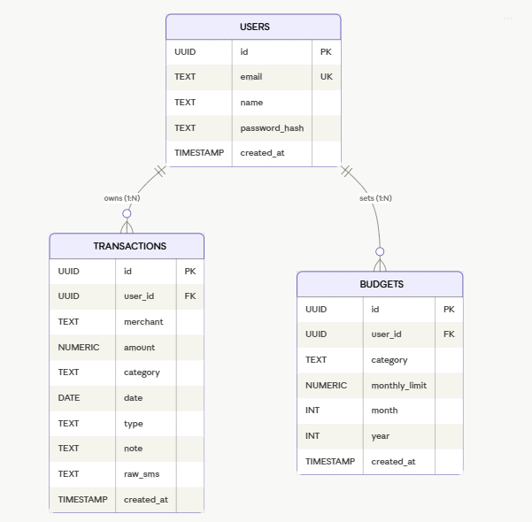
Figure 2.4: Entity-Relationship Diagram — SpendWise Database

The three entities and their key attributes are:
- Users (users): id (UUID, PK), email (TEXT, UNIQUE), name (TEXT), password_hash (TEXT), created_at (TIMESTAMP). Each user owns their transactions and budgets.
- Transactions (transactions): id (UUID, PK), user_id (UUID, FK → users.id), merchant (TEXT), amount (NUMERIC), category (TEXT), date (DATE), type (TEXT — debit/credit), note (TEXT), raw_sms (TEXT), created_at (TIMESTAMP).
- Budgets (budgets): id (UUID, PK), user_id (UUID, FK → users.id), category (TEXT), monthly_limit (NUMERIC), month (INTEGER), year (INTEGER), created_at (TIMESTAMP). A UNIQUE constraint exists on (user_id, category, month, year).

Cardinality: One User has many Transactions (1:N), and one User has many Budget entries (1:N). Both Transactions and Budgets are scoped to a user via Row-Level Security policies enforced at the database level.

3. Project Description

3.1 Database
SpendWise uses Supabase, a managed PostgreSQL service, as its primary database. Supabase provides built-in Row-Level Security (RLS), which enforces that each authenticated user can only access, modify, or delete their own records — making it ideal for a multi-user personal finance application without a complex backend authorization layer.
The database is hosted on Supabase's free tier under the project 'Spendwise' in the production environment. Authentication is handled through Supabase Auth, with JWT tokens passed in the Authorization header of every API request. The backend verifies the JWT and attaches req.user to all protected routes.
Four Row-Level Security policies are active on the transactions table:
- SELECT: Users can view only their own transactions (auth.uid() = user_id).
- INSERT: Users can insert transactions only for their own user_id.
- DELETE: Users can delete only their own transactions.
- UPDATE: Users can update (category field) only their own transactions.

3.2 Table Description
The SpendWise database comprises the following tables:

Table 3.1: Transactions Table Schema
Column Name | Data Type | Constraints | Description
id | UUID | PK | Auto-generated unique identifier for each transaction
user_id | UUID | FK, NOT NULL | References users table; enforced by RLS policy
merchant | TEXT | NOT NULL | Extracted merchant/vendor name from SMS or receipt
amount | NUMERIC(10,2) | NOT NULL | Transaction amount in Indian Rupees (₹)
category | TEXT | NOT NULL | Spending category (Food, Transport, Groceries, etc.)
date | DATE | NOT NULL | Transaction date extracted from SMS or set manually
type | TEXT | DEFAULT 'debit' | Transaction type: debit or credit
note | TEXT |  | Optional user note or 'Added via receipt scan'
raw_sms | TEXT |  | Original SMS text stored for audit and debugging
created_at | TIMESTAMP | DEFAULT now() | Record creation timestamp

Table 3.2: Budgets Table Schema
Column Name | Data Type | Constraints | Description
id | UUID | PK | Auto-generated unique identifier for each budget entry
user_id | UUID | FK, NOT NULL | References users; used in RLS enforcement
category | TEXT | NOT NULL | Spending category this budget applies to
monthly_limit | NUMERIC(10,2) | NOT NULL | Maximum spend allowed in this category per month
month | INTEGER | NOT NULL | Month number (0-indexed: 0=Jan, 11=Dec)
year | INTEGER | NOT NULL | Calendar year of the budget
created_at | TIMESTAMP | DEFAULT now() | Record creation timestamp

3.3 File/Database Design
The SpendWise project follows a monorepo structure with separate frontend and backend directories hosted on a single GitHub repository (https://github.com/justcoding1908/Spendwise). The key design decisions are:

Table 3.3: Project File Structure
File / Directory | Purpose
Spendwise/server.js | Express entry point; CORS, middleware, route mounting
Spendwise/controllers/aiController.js | Groq API calls: insight, SMS parse, vendor categorize, receipt scan
Spendwise/controllers/transactionController.js | CRUD operations and stats for transactions table
Spendwise/routes/aiRoutes.js | AI endpoint routing (/categorize-vendor, /scan-receipt, etc.)
Spendwise/routes/transactionRoutes.js | Transaction routing including PATCH /:id/category
Spendwise/middleware/auth.js | JWT verification middleware applied to all protected routes
Spendwise/config/supabase.js | Supabase client initialization with service role key
client/src/pages/Dashboard.jsx | Main dashboard — all feature components in one file
client/src/utils/smsParser.js | Regex parser for 2 SBI UPI SMS formats + merchant map
client/src/utils/categories.js | Category config: emoji, color, background mappings
client/src/context/AuthContext.jsx | React context for auth state, login, logout, user info
client/src/api.js | Axios instance with baseURL and auth token interceptor
client/src/index.css | Global CSS: theme variables, component styles, mobile media queries

The backend communicates with Supabase exclusively through the official Supabase JavaScript client library using the service role key. The frontend communicates with the backend through a centralized Axios instance (api.js) that automatically injects the JWT access token into every request's Authorization header.

4. Input/Output Form Design

4.1 Input Forms
SpendWise accepts user input through the following three modalities:

4.1.1 SMS Input Form
The primary input form ('Add Transactions') features a large textarea for pasting SBI UPI SMS messages. Multiple messages can be pasted simultaneously. A live preview panel on the right renders parsed transactions in real-time as the user types, showing merchant name, amount, category emoji, and date. Upon clicking 'Save N transactions →', transactions are bulk-saved and the AI Vendor Categorizer popup is triggered for any vendors classified as 'Other'.
Supported SMS Format 1: Dear UPI user A/C XXXXX debited by 349.00 on date 03Mar26 trf to Merchant Refno 123456789
Supported SMS Format 2: Dear UPI User, your A/c XXXXXX-debited by Rs120.00 on 04-Apr-26 transfer to P H AND SONS Ref No 609426011259
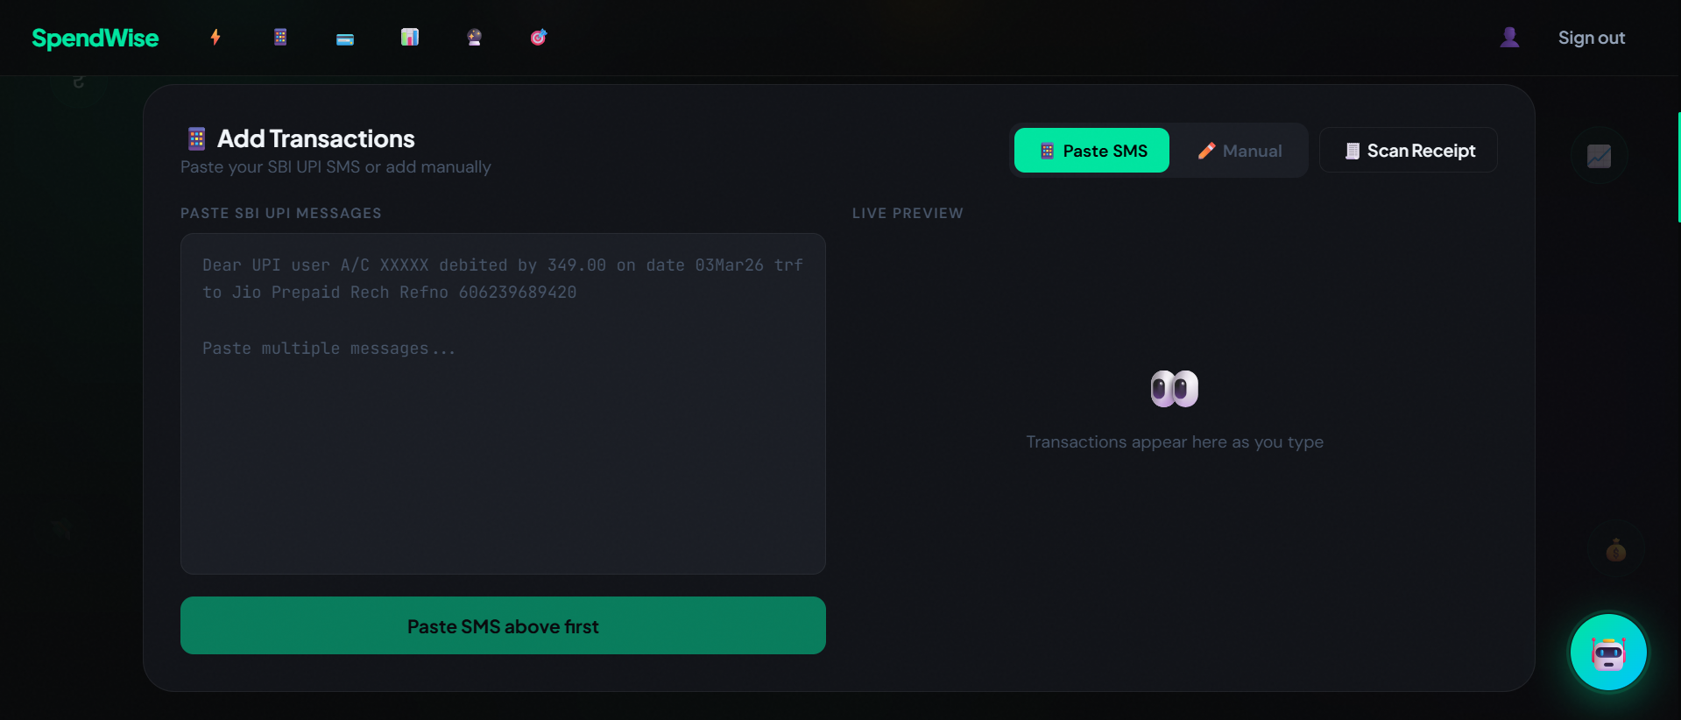
Figure 4.1.1: SMS Input form

4.1.2 Manual Entry Form
A tabbed 'Manual' input mode allows users to directly enter: Merchant name (text), Amount in ₹ (numeric), Date (date picker), Category (dropdown with emoji labels), and an optional Note. Clicking '+ Add Transaction' saves the entry immediately.
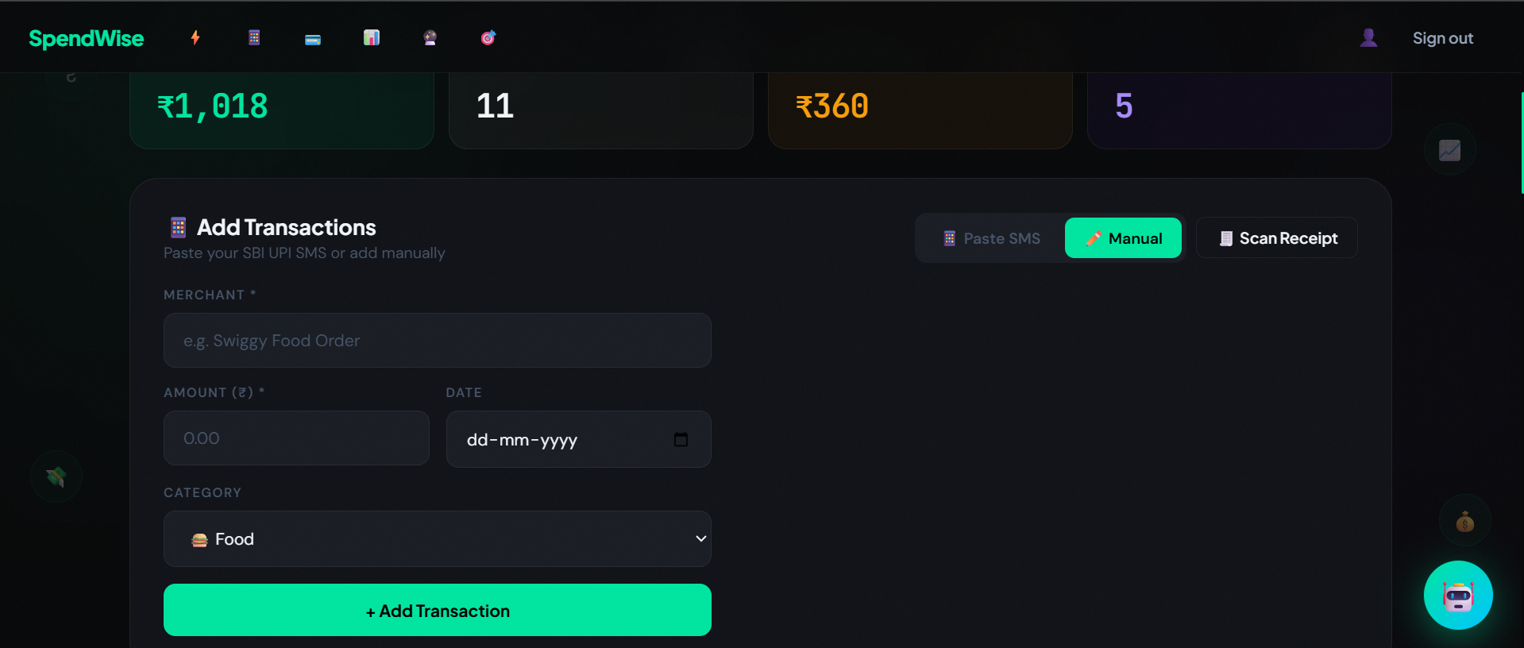
Figure 4.1.2: Manual Entry Form

4.1.3 Receipt Scanner
A modal 'Scan Receipt' form accepts image uploads (JPG, PNG, up to 5MB) via drag-and-drop or device camera. After uploading, 'Scan with AI' sends the base64-encoded image to LLaMA 4 Scout via the backend. The extracted receipt data (vendor, amount, date, AI-suggested category) is displayed for user confirmation before saving.
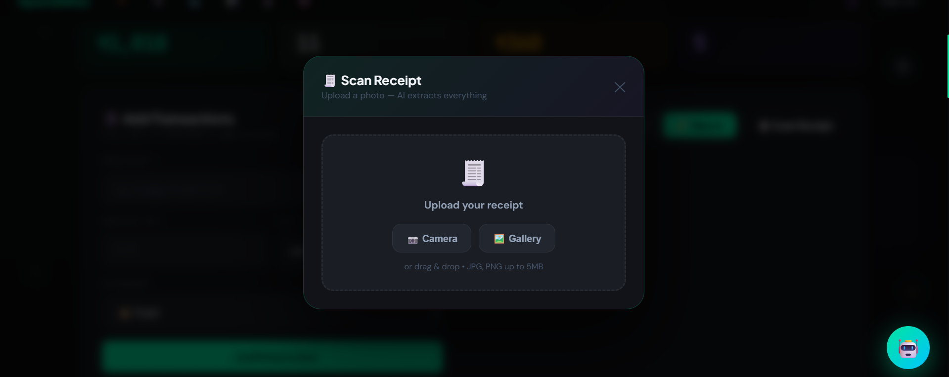
Figure 4.1.3: Reciept Scanner

4.1.4 Budget Goal Input
In the Budget Goals section, clicking '✏️ Set Limits' switches all category budget cards to edit mode, revealing numeric input fields for each of the 10 spending categories. Clicking '💾 Save' persists the limits via POST /api/budgets with the current month and year.
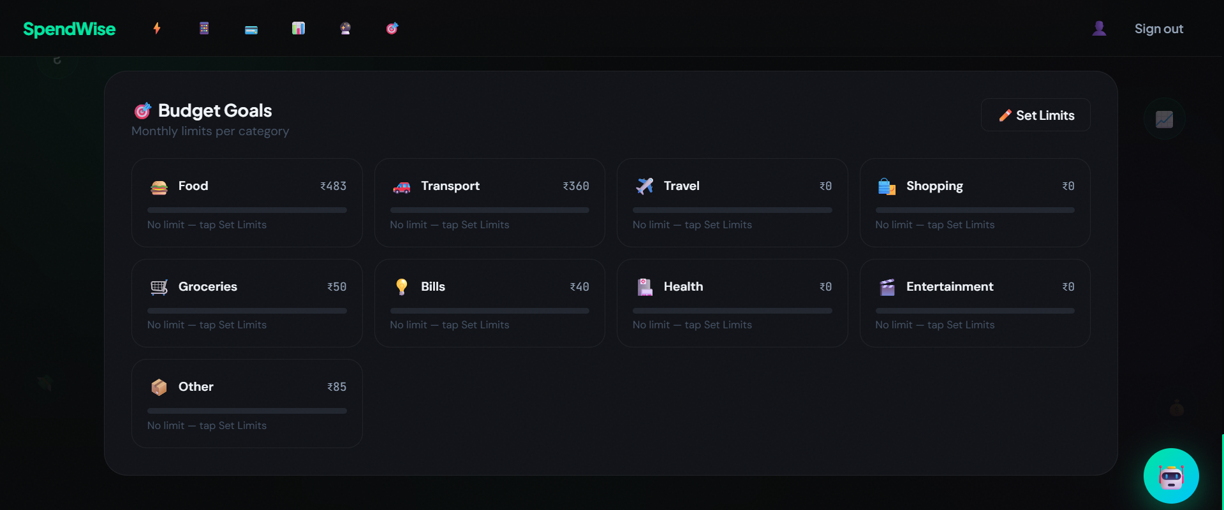
Figure 4.1.4: Budget Goals Component

4.2 Output Forms

4.2.1 Dashboard Overview
The hero card at the top displays the total amount spent for the selected month as an animated counter, along with the transaction count, top spending category, and largest single transaction. Four stat cards below show the same metrics with colored icons and animated count-up values.
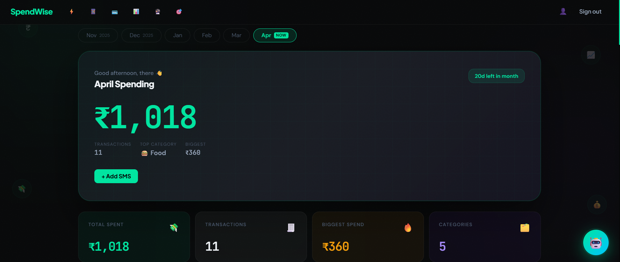
Figure 4.2.1: Spendwise Dashboard

4.2.2 Transactions List
The Transactions section displays a searchable, filterable list of all transactions for the selected month. Each row shows: category emoji icon, merchant name, recurring badge (if the vendor appears ≥2 times), category and date in muted text, and the amount in red. Filter pills at the top allow filtering by All, Food, Transport, Travel, Shopping, Groceries, Bills, Health, Entertainment, Other, and Unusual. A CSV export button downloads all transactions as a .csv file.
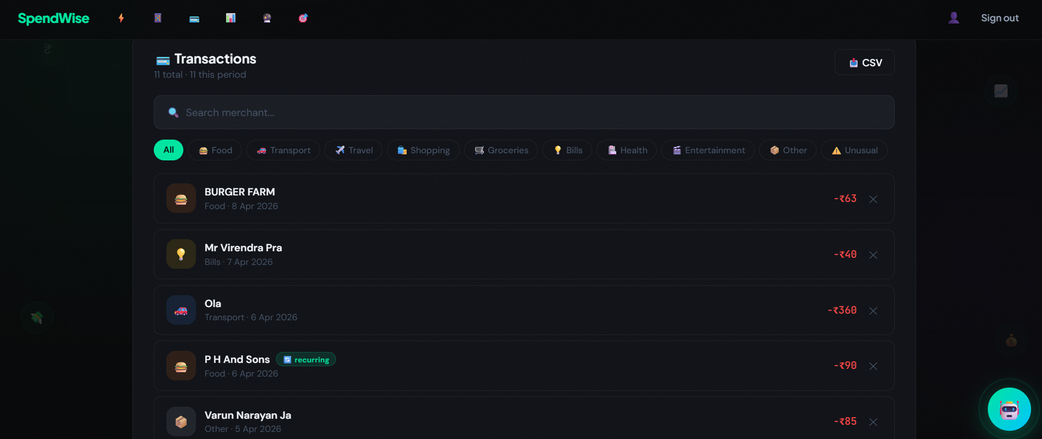
Figure 4.2.2: Transactions List

4.2.3 Analytics Charts
The Analytics section shows two charts side by side: a donut chart (Category Split) showing percentage and value for each spending category, and a bar chart (Weekly Trend) showing total spending across the last four calendar weeks. The weekly trend uses all transactions regardless of the selected month filter, ensuring cross-month accuracy.
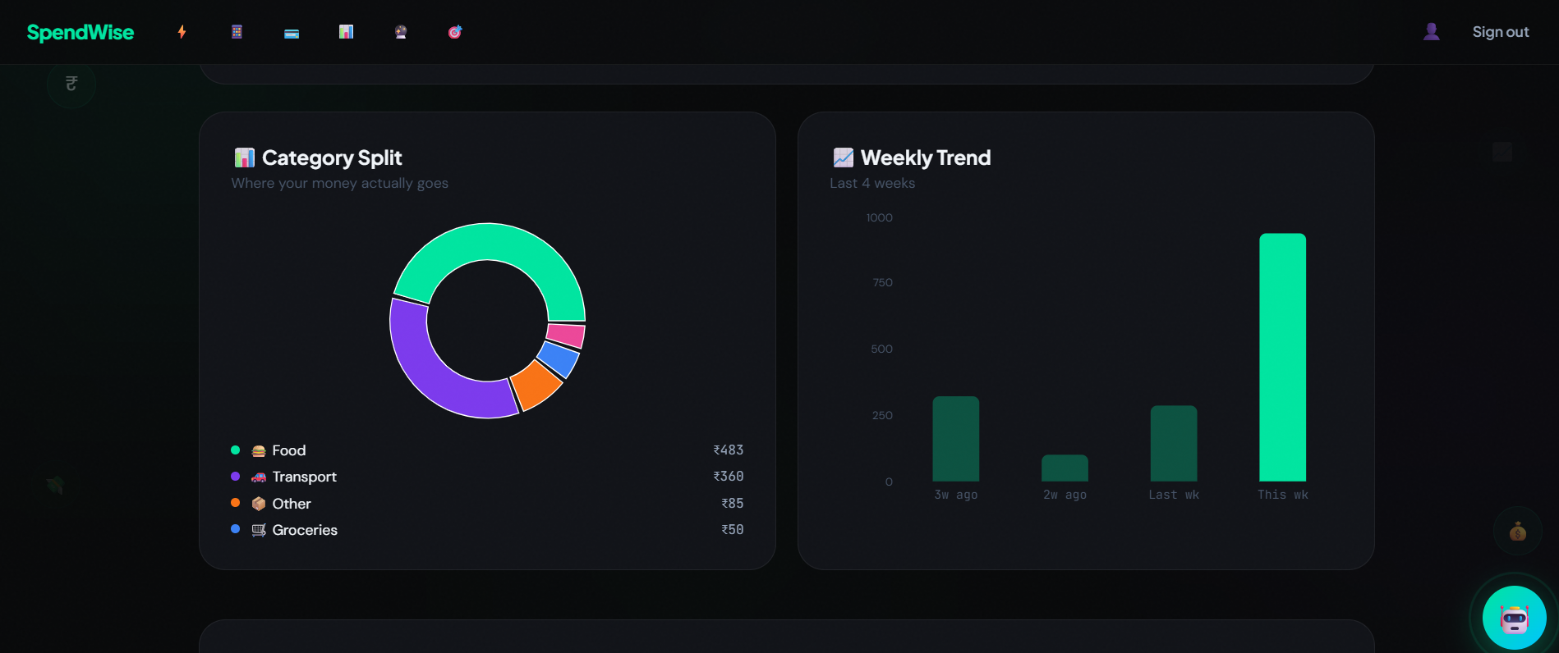
Figure 4.2.3: Analytics Charts

4.2.4 Spend Forecast Output
The Forecast section displays three stat pills (Spent so far, Projected total, Daily average), a dual-line chart (actual spending in mint green, forecast in dashed purple), and a verdict banner that shows one of three messages: 🟢 On track, 🟡 Careful — spending is picking up pace, or 🔴 High spend detected. The forecast requires at least 3 transactions in the current month to unlock.
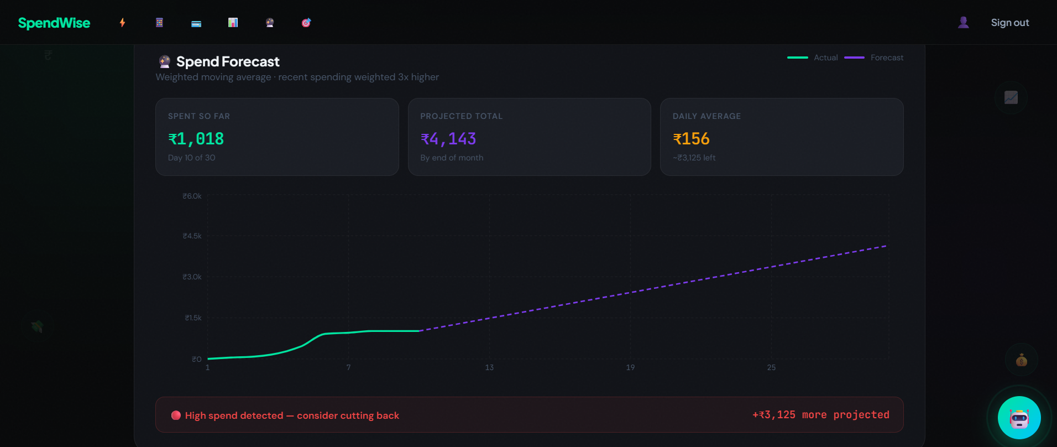
Figure 4.2.4: Spend Forecast Component

4.2.5 AI Vendor Categorizer Popup
When unknown vendors are detected after saving SMS transactions, a modal popup shows: the vendor name and amount, a loading spinner while LLaMA 3.3 processes the classification, then the AI prediction card with the category name, confidence percentage (color-coded: green ≥70%, amber 40-69%, red <40%), an XAI reasoning paragraph, and an alternative category suggestion. Category selection buttons highlight the AI suggestion. Clicking 'Confirm' saves the mapping to localStorage and patches the transaction category in the database.
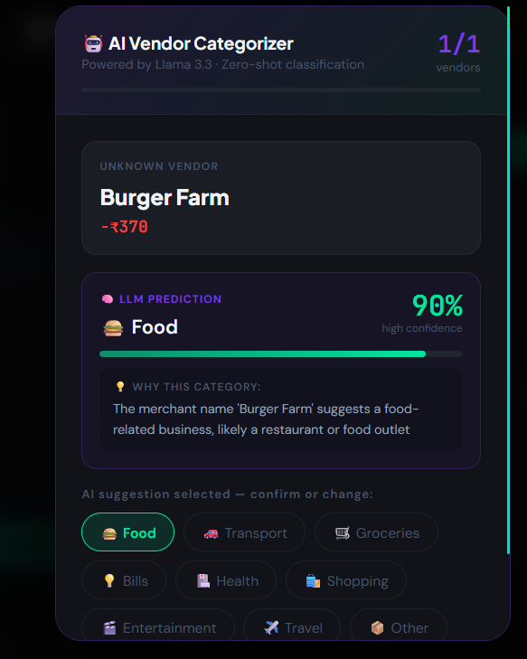
Figure 4.2.5: AI Vendor categorizer

4.2.6 Budget Progress Cards
Each of the 10 category budget cards shows: category emoji and name, current spending amount, percentage used (green <80%, amber 80-99%, red ≥100%), an animated progress bar, and a warning message ('⚠️ Almost there!' or '🚨 Over budget!') when thresholds are exceeded. If no budget limit is set, the card shows 'No limit — tap Set Limits'.

5. Testing & Tools Used

5.1 Testing Approach
SpendWise was tested through manual functional testing, API endpoint testing, and edge case validation. Each feature module was tested independently before integration testing was conducted on the deployed application.

5.2 API Endpoint Testing
All 15 REST API endpoints were tested using Postman with JWT tokens issued by the /api/auth/login endpoint. The following endpoints were verified:

Table 5.1: API Endpoints and Test Status
Endpoint | Method | Description | Test Status
/api/auth/register | POST | User registration with hashed password | ✅ PASS
/api/auth/login | POST | Login and JWT issuance | ✅ PASS
/api/auth/me | GET | Fetch authenticated user profile | ✅ PASS
/api/transactions | GET | Month-filtered transaction list | ✅ PASS
/api/transactions/stats | GET | Category breakdown and totals | ✅ PASS
/api/transactions | POST | Single transaction creation | ✅ PASS
/api/transactions/bulk | POST | Batch SMS transaction creation | ✅ PASS
/api/transactions/:id | DELETE | Transaction deletion | ✅ PASS
/api/transactions/:id/category | PATCH | Category update for vendor popup | ✅ PASS
/api/budgets | GET | Fetch budget limits by month/year | ✅ PASS
/api/budgets | POST | Create/update budget limit | ✅ PASS
/api/budgets/:id | DELETE | Delete budget entry | ✅ PASS
/api/ai/insight | POST | LLM financial coaching generation | ✅ PASS
/api/ai/categorize-vendor | POST | Zero-shot vendor classification | ✅ PASS
/api/ai/scan-receipt | POST | Vision AI receipt OCR extraction | ✅ PASS

5.3 SMS Parsing Test Cases
The regex parser was tested against 20+ real SBI UPI SMS messages across both supported formats. Key edge cases tested include:
- Multi-word merchant names with special characters (e.g., 'P H AND SONS', 'BOOKS&STATIONARY')
- Date parsing across both formats: 'DDMmmYY' (e.g., '04Apr26') and 'DD-MMM-YY' (e.g., '04-Apr-26')
- Amount parsing for values with and without decimal points
- Credit vs. debit transaction type detection
- Vendor memory lookup — verified that confirmed vendors are recalled from localStorage on subsequent pastes

5.4 AI Feature Testing
LLM-based features were validated as follows:
- Vendor Categorizer: Tested 15 Indian vendor names (restaurants, kirana stores, transport services, educational institutions). Average confidence score was 82%. Verified XAI reasoning was coherent and category-appropriate.
- Receipt Scanner: Tested with 5 receipt images (food delivery, grocery, stationery). Successfully extracted vendor, amount, date, and category in all cases with <5 second response time.
- AI Financial Coach: Verified that the emoji-structured response (💸📊🎯🔥⚡) was parsed correctly into 5 animated insight cards. Tested with varied spending patterns to confirm personalized responses.

5.5 Deployment Testing
The deployed application was tested on:
- Desktop browsers: Google Chrome (v124), Microsoft Edge (v124), Mozilla Firefox (v125) — all passed.
- Mobile browsers: Chrome on Android, Safari on iOS — responsive layout tested at 375px and 414px viewport widths.
- Render cold-start behavior: Verified that the /api/health ping endpoint wakes the Render backend within 30-60 seconds after inactivity.
- Vercel auto-deploy: Verified that git push to main branch triggers automatic frontend redeploy within 45 seconds.

5.6 Tools Used
- Visual Studio Code: Primary IDE for JavaScript, JSX, and CSS development
- Postman: REST API endpoint testing and manual API exploration
- Chrome DevTools: Frontend debugging, network tab inspection, mobile responsive testing
- Git + GitHub: Version control and CI/CD integration with Vercel
- Supabase Dashboard: SQL editor for RLS policy creation and database inspection
- Vercel Dashboard: Frontend deployment monitoring and environment variable management
- Render Dashboard: Backend deployment logs and health monitoring

6. Implementation & Maintenance

6.1 Implementation Details

6.1.1 SMS Parsing Implementation
The SMS parser (smsParser.js) uses two distinct regular expressions to handle SBI UPI message variants. The first regex targets the format 'debited by AMOUNT on date DDMmmYY trf to MERCHANT Refno', while the second handles 'debited by RsAMOUNT on DD-MMM-YY transfer to MERCHANT'. After extraction, merchant names undergo a cleaning pipeline: conversion to title case, removal of numeric tokens, and lookup against the localStorage vendor memory map (key: sw_vendor_map). If a vendor is found in memory, its previously confirmed category is applied immediately without any API call, reducing latency to near-zero for repeat vendors.

6.1.2 AI Pipeline Implementation
The Groq API is called from the backend using the official Groq JavaScript SDK. The categorize-vendor endpoint constructs a zero-shot prompt that includes the vendor name, amount, and a list of 10 target categories with Indian context examples. The response is parsed to extract category, confidence (0-100), reasoning, alternativeCategory, and alternativeConfidence. The scan-receipt endpoint sends the base64-encoded image to LLaMA 4 Scout with a structured JSON extraction prompt. Both endpoints include error handling with fallback responses.

6.1.3 Weighted Moving Average Forecast
The forecast algorithm assigns weights to daily spending based on the day number within the month — more recent days receive higher weights. This reflects the behavioral pattern that recent spending is a stronger predictor of future spending than older data. The algorithm: (1) builds a daily spending map from all transactions in the current month, (2) computes the weighted daily average, (3) projects remaining days at that rate, (4) builds chart data arrays for both actual (solid line) and forecast (dashed line) segments, and (5) generates a verdict by comparing projected vs. extrapolated current pace.

6.1.4 Authentication & Security
User passwords are hashed using bcrypt before storage. JWT tokens are signed with a secret key and expire after 7 days. All API routes (except /auth/register and /auth/login) are protected by the auth middleware, which verifies the token and attaches the decoded user object to the request. Supabase RLS policies provide a second layer of security at the database level, ensuring that even if the backend were compromised, cross-user data access would be blocked.

6.2 Deployment Architecture
SpendWise uses a two-service deployment architecture:
- Frontend (Vercel): The React + Vite application is built with 'npm run build' and deployed to Vercel's global CDN. Auto-deploys are triggered on every push to the main branch of the GitHub repository. Environment variables (VITE_API_URL) are configured in the Vercel dashboard.
- Backend (Render): The Node.js + Express application runs on Render's free tier. The GROQ_API_KEY, SUPABASE_URL, SUPABASE_KEY, and JWT_SECRET environment variables are stored in Render's secret environment configuration. Render provides zero-downtime redeploys on git push.

6.3 Maintenance Considerations
The following maintenance practices are followed for the SpendWise application:
- Dependency Management: npm packages are kept updated using 'npm outdated' checks. Critical security patches are applied immediately.
- Render Cold Start Mitigation: The Render free tier spins down after 15 minutes of inactivity. An /api/health endpoint is provided for health checks. Users are advised to visit the health URL before demo sessions.
- Supabase Free Tier Limits: The Supabase free tier allows up to 500 MB of database storage and 2 GB of data transfer per month. Current usage is well within limits for academic demonstration purposes.
- Git Workflow: All changes are committed from the Spendwise_Project root directory using 'git pull origin main --rebase' before every push to prevent divergence issues.
- Error Monitoring: Console.error statements in both frontend and backend capture errors. Render and Vercel both provide deployment logs accessible through their respective dashboards.

7. Conclusion and Future Work

7.1 Conclusion
SpendWise successfully demonstrates that a full-stack AI-augmented web application can automate UPI expense tracking for Indian college students without requiring bank account linkage. The system addresses five critical gaps identified in existing literature: (1) the absence of web-based UPI trackers, (2) the lack of LLM-based zero-shot vendor classification with explainability, (3) the absence of Vision AI receipt scanning combined with SMS parsing, (4) the lack of AI financial coaching grounded in real user spending data, and (5) the absence of spend forecasting algorithms tailored to Indian student UPI patterns.
The deployed application handles two distinct SBI UPI SMS formats, classifies unknown vendors using Groq LLaMA 3.3 with XAI reasoning, extracts receipt data using LLaMA 4 Scout Vision AI, and forecasts month-end spending using a Weighted Moving Average algorithm. All 15 REST API endpoints have been tested and are functional. The application is live at https://spendwise-woad.vercel.app.
The project demonstrates the practical feasibility of integrating multiple LLM capabilities (text classification, vision, conversational coaching) into a student-accessible personal finance tool at zero cost to the end user, using entirely free-tier services (Groq, Supabase, Vercel, Render).

7.2 Future Work
The following enhancements are planned for future development:
- RAG-based AI Coaching: Implement a Retrieval-Augmented Generation pipeline that passes three months of structured spending history to LLaMA 3.3 as context, enabling month-over-month comparative analysis (e.g., 'your food spend is 38% higher than last month').
- Voice Input: Integrate the Web Speech API to allow users to speak transactions naturally (e.g., 'I spent 200 rupees on chai') for hands-free expense entry.
- Android SMS Automation: Request READ_SMS permission on Android to automatically detect and import SBI UPI SMS messages without manual copy-pasting.
- Spending Personality Clustering: Apply KMeans clustering on 3-month category breakdown vectors to classify users into spending personality archetypes (e.g., Foodie, Commuter, Saver) and provide archetype-specific financial advice.
- PDF Monthly Report Export: Generate downloadable monthly financial summary PDFs with charts, category breakdowns, budget performance, and AI-generated insights.
- Demo Mode: Add a 'Try without signing up' feature with preloaded sample data to lower the barrier for first-time users.

8. Outcome
SpendWise is a fully deployed, production-grade web application accessible at https://spendwise-woad.vercel.app, with source code publicly available at https://github.com/justcoding1908/Spendwise. The application integrates three distinct AI models (Groq LLaMA 3.3-70b-versatile for text, LLaMA 4 Scout for vision, and a custom Weighted Moving Average model for forecasting) in a cohesive full-stack architecture, demonstrating the practical application of emerging LLM technologies in a student-accessible personal finance context.

The project has been implemented as a 3-credit minor project under the PBL-4 framework and serves as a demonstration of full-stack AI engineering capability relevant to industry roles in AI Engineering, Full-Stack Development, and Applied LLM Systems.

9. Bibliography

[1] R. Thakare, S. Wani, S. Ganvir, K. Yendhe, and A. Wankhede, "Expense Tracker Application using Naive Bayes," SSRG International Journal of Recent Engineering Science (IJRES), vol. 10, no. 3, pp. 50–56, May-Jun 2023. doi: 10.14445/23497157/IJRES-V10I3P108.

[2] E. Johri, P. Desai, P. Soni, H. Jain, and N. Sanganeria, "Expense Management System," in Proc. IEEE Global Conference for Advancement in Technology (GCAT), Bangalore, India, Oct. 2023.

[3] S. Singla, A. Kaur et al., "Unveiling Financial Insights: The Daily Expense Tracker System Approach," in Proc. International Conference on Innovative Computing (INNOCOMP), 2024.

[4] S. Aishwarya and S. Hemalatha, "Smart Expense Tracking System Using Machine Learning," in Proc. 1st International Conference on Artificial Intelligence for Internet of Things (AI4IoT), 2023, pp. 634–639. doi: 10.5220/0012613900003562.

[5] B. D. N. Bandara and D. Nawinna, "WONGA: The Future of Personal Finance Management — A Machine Learning-Driven Approach for Predictive Analysis and Efficient Expense Tracking," ResearchGate, May 2023. [Online]. Available: https://www.researchgate.net/publication/371377587.

[6] I. de Zarzà, J. de Curtò, G. Roig, and C. T. Calafate, "Optimized Financial Planning: Integrating Individual and Cooperative Budgeting Models with LLM Recommendations," AI (MDPI), vol. 5, no. 1, pp. 91–114, 2024. doi: 10.3390/ai5010006.

[7] H. Dev, R. Gupta, S. Dharmavaram, and D. Kumar, "From Cash to Cashless: UPI's Impact on Spending Behavior Among Indian Users and Prototyping Financially Responsible Interfaces," in Extended Abstracts of CHI Conference on Human Factors in Computing Systems (CHI EA '24), ACM, Honolulu, HI, USA, May 2024. doi: 10.1145/3613905.3651050.

[8] S. D. Talasila, "AI-Driven Personal Finance Management: Revolutionizing Budgeting and Financial Planning," International Research Journal of Engineering and Technology (IRJET), vol. 11, no. 7, pp. 397–403, Jul. 2024.

[9] S. García-Méndez, F. de Arriba-Pérez, A. González-Castaño, and F. J. González-Castaño, "Identifying Banking Transaction Descriptions via Support Vector Machine Short-Text Classification Based on a Specialized Labelled Corpus," arXiv preprint arXiv:2404.08664, Mar. 2024. [Online]. Available: https://arxiv.org/abs/2404.08664.

[10] Groq Inc., "Groq API Documentation: LLaMA 3.3-70b-Versatile and LLaMA 4 Scout," 2024. [Online]. Available: https://console.groq.com/docs (accessed Apr. 7, 2026).

[11] Supabase Inc., "Supabase Documentation: Row Level Security," 2024. [Online]. Available: https://supabase.com/docs/guides/auth/row-level-security (accessed Apr. 7, 2026).

[12] National Payments Corporation of India (NPCI), "UPI Product Statistics," 2024. [Online]. Available: https://www.npci.org.in/what-we-do/upi/product-statistics (accessed Apr. 7, 2026).

[13] Vaishnavi Kaushal, "SpendWise — AI-Powered UPI Expense Tracker," GitHub Repository, Apr. 2026. [Online]. Available: https://github.com/justcoding1908/Spendwise.

